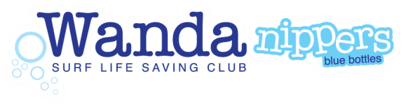
Wanda Nippers Board Hire Program
2021 / 2022 Season

Wanda JAG is proud to be able to offer a Board Hire program to Nipper families, where Nippers can hire a club owned board to use whilst at Nippers, training and competing at carnivals throughout the season.

Wanda JAG will continue to provide Nipper boards for general Sunday Nipper use, outside of the board hire program.
- Foamie Nipper Boards for use by U9 & U10 Nippers only
- Fibreglass Nipper Boards for use by U11-13 Nippers only
- Fibreglass Mal Boards for use by U14 Nippers only
All Boards should be returned to the Nipper Board shed at the completion of training or Nippers.
Age Managers should ensure this occurs every Sunday after water activities are completed.

Those Nipper families who take advantage of the Board Hire program are expected to bring their Hired Nipper board to use at Training, Carnivals and Sunday Nipper Activities.

Costs for Board Hire Program 2021/22 :

As new Fibreglass Nipper Board: $300 for the season (U11-13)

As new Foamie Nipper Board: $100 for the season (U9-10)

Board Cover cost is included in the hire of Fibreglass Nipper Boards.

Extended pre/off season use: $50 for the off/pre -season (U9-13)

Terms & Conditions of Hire Program:

Boards will be allocated to the U9-13 age groups by the Gear Steward and preference will be given to those Nippers that regularly attend training and carnivals.
Boards will be inspected by the Gear Steward and the parent / hirer at the time of allocation.
Any repairs required on the board during the hire period are to be paid for by the hirer / parent.
Loss or non-return of the board and/or board cover will result in the hirer / parent being responsible for the cost of the replacement board and/or board cover.
Continued absence at training and non-attendance on Sundays may result in the board being re-allocated.
Allocated boards must be brought to training and nippers.

All Club Owned boards must be returned at the end of the season.

Boards should be stored and transported inside a suitable cover.
Boards should be carried and not dragged on the beach. Boards should not be left lying in the sun for extended periods of time (to avoid bubbling of the board).
Boards should not be thrown onto the sand. When you have finished using a board you should wash the board down with fresh water.
Any mistreatment of boards will result in the loss of usage rights to that equipment.

Any damage must be reported immediately to the Gear Steward.

